Annexure B – Checklist Document for Eligibility Criteria on letter head
Sl No | Criteria | Documents Required | Compliance (Y/N)
 | The Vendor/SI should be a company registered under Companies Act, 1956 and Companies Act 2013/ LLP registered under LLP Act, 2008. The Vendor should be registered for GST. It should not be individual/ proprietorship firm/ HUF/ partnership firm etc. | Copy of the certificate of Incorporation issued by the registrar of companies.
 | Average Annual Turnover / Revenue for last 3 financial years (F.Y. 2023-24, 2024-2025, 2025-2026 as per audited Balance of FY 2025-2026): > Rs. 75 Crores and For MSME / Startup > Rs. 50 Crores.  The Vendor should have a positive Net worth and PAT(Profit after Tax) in the last financial year (F.Y. 2025-26).  Further, Vendors note that credentials of the parent company will be considered in case the Vendor is a 100% subsidiary of the parent company. | Copies of the audited balance sheet of the company showing turnover of the company for financial years (F.Y. 2023- 24, 2024-2025, 2025-2026) should be submitted as part of the documentary proof. (For FY 2025-26 Unaudited balance sheet Certified by Chartered Accountant)  Certificate of the Chartered Accountant for positive Net worth without any qualification / remarks to be submitted. (Annexure D)  Copy of MSME / Start-up registration certificate
 | Vendor/Parent Company of the Vendor/Promoter(s) of the Vendor should not be under debarment/blacklist period for breach of contract/fraud/corrupt practices by any Scheduled Commercial Bank/ Public Sector Undertaking /any regulatory body etc., IBA, RBI, or State or Central Government or their agencies/ departments on the date of submission of Application for this EOI. In case of merger /acquisition / purchase / takeover, this clause would be applicable to both the organisations. i.e., in case any one of the organisations is blacklisted, then the same would be applicable to both organisations. Any instance of termination of SLA by any entity due to non-performance of the Applicant for the reasons attributable to the Applicant or their respective partner, during last 3 years prior to the date of EOI, shall be treated as non-performance on the part of the Applicant and its partner and such Applicants shall not be considered eligible for implementation of the project. (Company has sole right to terminate the agreement with immediate effect if any such case is found). | Self-declaration to this effect on the Vendor(s) letter head should be submitted. (Annexure- E)
 | The Vendor should be in business of providing Business Correspondent /Fintech/ Banking Agent / Doorstep Banking Services for Scheduled commercial banks / Financial Institutions / NBFC’s for at least 3 years in at least *10 states or above as per Annexure F attached as a separate sheet, as on the date of submission of the response. | Self-declaration along with Copy of Letter from Vendor/ Agreement with the client is to be submitted; and Details of Support organization structure is to be provided indicating the states covered, number of people present by each state and the names of the Scheduled commercial banks / Financial Institutions / NBFC’s where these services are being provided on the letter head of the company signed by the appropriate authority.
 | The Vendor , its shareholders, directors or partners  a. have not defaulted in any loan repayment or entered into an OTS with lenders during last 5 years or subject to any insolvency proceedings under IBC, 2016  b. No criminal suit was filed and pending during last 5 years for any offence under the BNS/ PMLA or any other Act. | Declaration on letterhead of Company mentioning  a. have not defaulted in any loan repayment or entered into an OTS with lenders during last 5 years or subject to any insolvency proceedings under IBC, 2016  b. No criminal suit was filed and pending during last 5 years for any offence under the BNS/ PMLA or any other Act.
 | The Vendor on their roles should at least have 1000 employees (Including Agents / supervisors/Business Correspondent). Excluding Trainees | Letter of confirmation (self-certified letter) highlighting number of employees, job roll wise bifurcation duly signed by the authorized signatory.
 | The Vendor should not have any Service Level Agreement pending to be signed with the any Banks/NBFCs for more than 6 months from the date of submission of EOI. | Vendor should specifically confirm on their letter head in this regard.
 | The Vendor should agree to the terms and conditions of Service Level Agreement to execute a contract with the Company. | Vendor should specifically confirm on their letter head in this regard.
 | Vendor should submit an Under-taking regarding compliance of all Laws, Rules, Regulations, Bye-Laws, Guidelines, Notifications existing as on date or to be issued from time to time by statutory/ regulatory bodies etc. | An undertaking on the letterhead of the Vendor has to be submitted (Annexure G)
 | The Vendor should have GST registration certificate, E.S.I.C., P.F. and applicable Labor Law registration/Licenses | A copy of PAN/TAN/GST Registration No. (Whichever applicable) in the name of Applicant Compliance/self-certificate along with Photocopies of valid registration certificates / licenses should be furnished along with the application
 | The Collection Agency should not be owned or controlled by any of the Directors or present employees (or relatives as defined under the Companies Act, 2013) of PSB Alliance Pvt. Ltd. & its member banks. | Self-declaration on the Collection Agency’s letter head
 | For vendors already serving / having served PSB Alliance in doorstep banking services a letter for satisfactory service delivery signed by the authorized signatory should be attached. | Letter for satisfactory service delivery signed by the authorized signatory should be attached.

ANNEXURE - C
(EOI offer forwarding letter)

To,
The Doorstep Banking Project Manager,
PSB Alliance Private Limited,
Unit 1, 3rd Floor,
VIOS Commercial Tower,
Wadala East, Mumbai 400037

Dear Sir / Madam,

EOI FOR SELECTION OF BUSINESS CORRESPONDENTS FOR PROVIDING DOORSTEP BANKING SERVICES THROUGH DOORSTEP BANKING AGENTS. EOI REFERENCE NO. PSBA/DSBSR/2026-27/0260Dated: 07-08-2026.

1.The EOI application fee of INR 10,000/- (Rupees Thirty Thousand only) and EMD as specified in EOI point 4.1 by way of two (2) DD respectively, drawn in favor of "PSB Alliance Private Limited", payable at Mumbai

2.In the event of acceptance of our Eligibility by the Company, we undertake the process of Company for Selection of Correspondents for Implementation of Services through Agents as per your work orders/requirement. 3. We shall submit an unconditional and irrevocable Performance Bank Guarantee (PBG) of ₹10,00,000 (Rupees Ten Lakh only) for each State for which empanelled. The PBG shall be furnished within 15 days from the date of issuance of the Letter of Award (LoA) or Purchase Order, in the format prescribed by the Company, and shall remain valid for the entire contract period plus a claim period of twelve (12) months. Failure to submit the PBG within the stipulated time may result in cancellation of the award.

4. We agree to abide by the terms and conditions of this EOI and our offer shall remain valid up to
27-08-2026 and it remain binding upon us which may be accepted by the Company any time before expiry.

5.Until a formal contract is executed, this application offer, together with the Company’s written acceptance thereof and Company’s notification of award, shall constitute a binding contract between us.

6. We understand that the Company is not bound to accept any offer the Company may receive. We also certify that we have not been blacklisted by any PSU Company/IBA/RBI during the last five years and also at the time of submission of application.

Yours faithfully,
For: [•]

(Signature and seal of authorized person)
Name:
Designation:
Place:
Date:

ANNEXURE – D

EOI for Selection of Business Correspondents for Provision of Doorstep Banking Services through Doorstep Banking Agents EOI REFERENCE NO. PSBA/DSBSR/2026-27/0260 Dated: 07-08-2026

FINANCIAL CERTIFICATE
(To be provided by Statutory Auditor/Chartered Accountant)

This is to certify that M/s [•], a Company/ LLP with its
Registered Office at [•], has the following Net worth and Profit after Tax from its Indian Operations. This information is based on the Audited Financial Statements for 2023-24, 2024-25 & 2025-26.

Financial Year | Net Profit/Loss (in Rs.) | Net Worth (in Rs.)
2023-24
2024-25
2025-26

Date: ___________
Place: ___________

Signature of CA/Statutory Auditor

Name of CA/Statutory Auditor:

Designation:

Seal of Company

ANNEXURE– E

UNDERTAKING TO BE GIVEN ON THE LETTERHEAD BY THE VENDOR TO ABIDE BY ALL TERMS AND CONDITIONS/NON-BLACKLISTING

To,
The Doorstep Banking Project Manager
PSB Alliance Private Limited,
4 th Floor, VIOS Commercial Tower,
Wadala East,
Mumbai
MUMBAI 400 037

Dear Sir/Madam

EOI FOR SELECTION OF BUSINESS CORRESPONDENTS FOR PROVIDING DOORSTEP BANKING SERVICES THROUGH DOORSTEP BANKING AGENTS EOI REFERENCE NO. PSBA/DSBSR/2026-27/0260 DATED:07-08-2026.

i We, M/s [•], the undersigned, hereby confirm that we have read and understood the eligibility criteria as given under EOI and will fulfil the same.
ii We further confirm that all the information as per requirement of the Company have been included in our application documents.
iii We hereby undertake and agree to abide by all terms and conditions and guidelines stipulated by the Banks/Company. We understand that any deviation may result in disqualification of our application.
iv We have not been blacklisted by any Nationalized bank/ Company/ undertaking /RBI/IBA or any other Government or Regulatory agency. No legal action is pending against us for any cause in any legal jurisdiction.
v We undertake that adequate number of resources, if required by the Banks/Company, will be deployed for the project to complete the assignment as required within stipulated time.
vi We confirm that we will provide the Hardware/ Software/ Manpower/Vehicle etc. as required for Doorstep Banking Services.

Yours faithfully,
For: [•]

(Signature and seal of authorized person)
Name:
Designation:
Place:
Date:

Annexure – F

General Details of the vendor
[On Vendor’s letter head]

A. Profile of Vendor

1. Name of vendor:
- Location Regd. Office:
Controlling Office:
- Constitution
- Date of incorporation & Date of Commencement of business:
- Major change in Management in last three years
- Names of Company/s
- Particulars of Authorized Signatory:
- Name
- Designation
- Address
- Phone No. (landline)
Mobile No.
- E-Mail Address

- Financial Position of Vendor for the last three financial years

Particulars | 2023-24 | 2024-25 | 2025-26
Net Worth
Annual Turnover
Net Profit (PAT)

N.B. Enclose copies of Audited Balance Sheets along with enclosures

- Proposed Service details in brief :

- Description of service: Details of similar service provided to PSU organization/BFSI in India specifying the number of Company and branches

- Details of Experience in the field of EOI for Selection of Correspondents for Implementation of Doorstep Banking

- Services by Business Correspondents through Doorstep Banking Agents.

BFSI / Organisation
 | Period
 | From | To

N.B. Enclose copies of Agreement and references

Signature of Vendor: __________________
Place : ___________
Name : _____________________________
Date: ____________
Business Address: ___________________

Seal of the Company

Annexure – G

Undertaking on the letterhead of the Vendor for application with all By-Laws / Rules / Regulations

To,

The Doorstep Banking Project Manager
PSB Alliance Private Limited,
Unit No 301, 3rd Floor, VIOS Commercial Tower,
Wadala East,
Mumbai
MUMBAI 400 037

EOI FOR SELECTION OF BUSINESS CORRESPONDENTS FOR PROVIDING DOORSTEP BANKING SERVICES THROUGH DOORSTEP BANKING AGENTS EOI REFERENCE NO PSBA/DSBSR/2026-27/0260DATED: 07-08-2026

Declaration-Cum-Undertaking regarding compliance with all statutory requirements

Further to our proposal dated [•], in response to the Expression of Interest (“EOI”) bearing No. PSBA/DSBSR/2026-27/0260issued by PSB Alliance Private Limited (“Company”), we hereby covenant, warrant, confirm and agree to comply with all Laws, Rules, Regulations, Bye-Laws, Guidelines, Notifications existing as on date or to be issued from time to time by statutory/ regulatory bodies etc.

We agree that any loss caused to the Banks/Company owing to our non-performance as per the Service Level Agreement, or noncompliance of regulatory guidelines, will attract liquidated damages to the extent that the claim is made against the Banks/Company.

We do also hereby irrevocably and unconditionally agree and undertake to save and keep the Banks/Company, including its respective directors, officers, and employees and keep them harmless from and against any claim, demand, losses, liabilities or expenses of any nature and kind whatsoever and any damage caused from and against all suits and other actions that may be instituted taken or preferred against the Banks/Company by whomsoever and all losses, damages, costs, charges and expenses arising out of noncompliance with or non adherence to any statutory/regulatory requirements and/or any other law for the time being in force.

Yours faithfully,
For: [•]

(Signature and seal of authorized person)
Name:
Designation:
Place:
Date:

Annexure H
[To be executed on a stamp paper of appropriate value]

NON-DISCLOSURE AGREEMENT

THIS NON-DISCLOSURE AGREEMENT (the “NDA”) is made at Mumbai on this [•] day of [•], 2026;

By and between:

PSB Alliance Private Limited a company incorporated under the Companies Act, [1956/2013] and having its registered office at Unit No 1, 3rd Floor, VIOS Commercial Tower, Wadala East, Mumbai 400 037 (hereinafter referred to as “Company” which expression includes its successors and assigns) of the ONE PART;

And

M/s. [•] an entity existing under the laws of [•] having its registered office at [•] (hereinafter referred to as “Correspondent” or the “Receiving Party” which expression shall unless repugnant to the subject or context thereof, shall mean and include its successors and permitted assigns) of the OTHER PART;

Whereas:

- Correspondent had submitted its in response to the EOI FOR SELECTION OF BUSINESS CORRESPONDENTS FOR PROVIDING DOORSTEP BANKING SERVICES THROUGH DOORSTEP BANKING AGENTS EOI REFERENCE NO. PSBA/DSBSR/2026-27/0260DATED: 07-08-2026 issued by the Company for and on behalf of the Banks and upon being successful has agreed to provide Doorstep Banking Services (Services) through Doorstep Banking Agents (Agents) for the Banks/Company and other related tasks (“Purpose”).

- For purposes of advancing the business relationship, the Disclosing Parties would need to disclose certain valuable confidential information to the Receiving Party. Therefore, in consideration of covenants and agreements contained herein for the disclosure of confidential information, and intending to be legally bound, the parties agree to terms and conditions as set out hereunder.

NOW IT IS HEREBY AGREED BY AND BETWEEN THE PARTIES AS UNDER

1. Confidential Information and Confidential Materials:

- “Confidential Information” means non-public information that Disclosing Parties designates as being confidential or which, under the circumstances surrounding disclosure ought to be treated as confidential and includes, without limitation, information relating to installed or purchased Disclosing Parties software or hardware products, the information relating to general architecture of Disclosing Parties network, information relating to nature and content of data stored within network or in any other storage media, Disclosing Parties business policies, practices, methodology, policy design delivery, and information received from others that Disclosing Parties is obligated to treat as confidential. Confidential Information disclosed to Receiving Party by any Disclosing Parties Subsidiary and/ or agents is covered by this NDA.

- Confidential Information shall not include any information that: (i) is or subsequently becomes publicly available without Receiving Party’s breach of any obligation owed to Disclosing Parties; (ii) becomes known to Receiving Party prior to Disclosing Parties disclosure of such information to Receiving Party; (iii) became known to Receiving Party from a sources other than Disclosing Parties other than by the breach of an obligation of confidentiality owed to Disclosing Parties; or (iv) is independently developed by Receiving Party.

- “Confidential Materials” shall mean all tangible materials containing Confidential Information, including without limitation written or printed documents and computer disks or tapes, whether machine or user readable.

2. Restrictions

- Receiving Party shall treat as confidential the all Confidential Information obtained from the other pursuant to the Purpose and shall not divulge such information to any person (except to its own employees and other persons who need to know the same) without the Disclosing Parties written consent. Receiving Party will execute appropriate written agreements with its employees and consultants specifically assigned and/or otherwise, sufficient to enable it to comply with all the provisions of this NDA. If the Correspondent shall appoint any agent, then Correspondent may disclose Confidential Information to such agent subject to such agent giving the Disclosing Parties an undertaking in similar terms to the provisions of this clause.

- Receiving Party may disclose Confidential Information in accordance with judicial or other governmental order to the intended recipients (as detailed in this clause), provided Receiving Party shall give Disclosing Parties reasonable notice prior to such disclosure and shall comply with any applicable protective order or equivalent restriction as imposed herein. The intended recipients for this purpose are the statutory auditors of the Receiving Party and regulatory authorities regulating the affairs of the Receiving party and inspectors and supervisory bodies thereof;

- The foregoing obligations as to confidentiality shall survive any termination of this Agreement.

- Confidential Information and Confidential Material may be disclosed, reproduced, summarized or distributed only in pursuance of Receiving Party’s business relationship with Disclosing Parties, and only as otherwise provided hereunder. Receiving Party agrees to segregate all such Confidential Material from the confidential material of others in order to prevent mixing.

- Receiving Party may not reverse engineer, decompile or disassemble any software disclosed to Receiving Party.

3. Rights and Remedies

- Receiving Party shall notify Disclosing Parties immediately upon discovery of any unauthorized used or disclosure of Confidential Information and/ or Confidential Materials, or any other breach of this NDA by Receiving Party and will cooperate with Disclosing Parties in every reasonable way to help Disclosing Parties regain possession of the Confidential Information and/ or Confidential Materials and prevent its further unauthorized use.

- Receiving Party shall return all originals, copies, reproductions and summaries of Confidential Information or Confidential Materials at Disclosing Parties request, or at Disclosing Parties option, certify destruction of the same.

- Receiving Party acknowledges that monetary damages may not be the only and / or a sufficient remedy for unauthorized disclosure of Confidential Information and that Disclosing Parties shall be entitled, without waiving any other rights or remedies (as listed below), to injunctive or equitable relief as may be deemed proper by a Court of competent jurisdiction.

- Suspension of access privileges;
- Change of personnel assigned to the job;
- Financial liability for actual, consequential or incidental damages;
- Termination of contract/Service Level Agreements.

- Disclosing Parties may visit Receiving Party’s premises, with reasonable prior notice and during normal business hours, to review Receiving Party’s compliance with the term of this NDA.

4. Miscellaneous

- All Confidential Information and Confidential Materials are and shall remain the property of Disclosing Parties. By disclosing information to Receiving Party, Disclosing Parties do not grant any expressed or implied right to Receiving Party to disclose information under the Disclosing Parties patents, copyrights, trademarks, or trade secret information or any other intellectual property rights.

- Any software and documentation provided under this NDA is provided with RESTRICTED RIGHTS.

- Disclosing Parties do not grant the Receiving Party any license, by implication or otherwise, to use the Confidential Information, other than for the limited purpose of evaluating or advancing a business relationship between them, or any license rights whatsoever in any patent, copyright or other intellectual property rights pertaining to the Confidential Information.

- This NDA constitutes the entire agreement between the parties with respect to the subject matter hereof. It shall not be modified except by a written agreement dated subsequently to the date of this NDA and signed by the parties. None of the provisions of this Agreement shall be deemed to have been waived by any act or acquiescence on the part of Disclosing Party, its agents, or employees, except by an instrument in writing signed by an authorized officer of Disclosing Parties. No waiver of any provision of this Agreement shall constitute a waiver of any other provision(s) or of the same provision on another occasion.

- This NDA shall be governed by Indian laws. In case of any dispute, both the parties agree to settle the dispute through mutual consultation. In the event they are unable to resolve the dispute within 15 days then they will refer the dispute to neutral third party sole arbitrator. Such arbitrator will be jointly selected by the parties. In the event the parties are unable to appoint the arbitrator within 15 days of invoking arbitration then the arbitrator shall be appointed by making a reference to the Mumbai High Court under the applicable provisions of the Arbitration and Conciliation Act, 1996. The arbitration proceedings shall be conducted in English language at Mumbai and in accordance with the provisions of Indian Arbitration and Conciliation Act, 1996 or any amendments or re-enactments thereto. The courts in Mumbai shall have exclusive jurisdiction over any dispute arising under this NDA. Disclosing Parties shall be at a liberty to approach any appropriate forum to seek appropriate injunctive relief.

- Subject to the limitations set forth in this NDA, this NDA will inure to the benefit of and be binding upon the parties, their successors and assigns.

- If any provision of this Agreement shall be held by a court of competent jurisdiction to be illegal, invalid or unenforceable, the remaining provisions shall remain in full force and effect.

- All obligations created by this Agreement shall survive change or termination of the parties’ business relationship.

NOW THIS NDA IS EXECUTED ON THE DATE AS MENTIONED HEREIN ABOVE

For and on behalf of the Company: | For and on behalf of the Business Correspondents:
Signature: | Signature:
Name: | Name:
Designation: | Designation:
Place: | Place:
Date: | Date:

ANNEXURE – I

UNDERTAKING LETTER TO THE COMPANY ON THE VENDOR’S LETTERHEAD FOR NON DEVIATION

To,
The Doorstep Banking Project Manager
PSB Alliance Private Limited,
Unit No 1, 3rd Floor, VIOS Commercial Tower,
Wadala East,
Mumbai
MUMBAI 400 037

Dear Sir / Madam,

EOI FOR SELECTION OF BUSINESS CORRESPONDENTS FOR PROVIDING DOORSTEP BANKING SERVICES THROUGH DOORSTEP BANKING AGENTS. EOI REFERENCE NO. PSBA/DSBSR/2026-27/0260DATED: 07-08-2026

Further to our proposal dated [•], in response to the Expression of Interest (“EOI”) bearing No. PSBA/DSBSR/2026-27/0260dated 07-08-2026, issued by PSB Alliance Private Limited (“Company”) on behalf of Banks, we hereby covenant, warrant and confirm that we shall comply with all the terms and conditions / stipulations as contained in the EOI and the related addendums and other documents including the changes made to the original EOI documents if any, issued by the Company. The Company is not bound by any other extraneous matters or deviations, even if mentioned by us elsewhere either in our proposal or any subsequent deviations sought by us, whether orally or in writing, and the Company’s decision not to accept any such extraneous conditions and deviations will be final and binding on us.

Yours faithfully,
For [•]:
Designation:

(Signature and seal of authorized person)
Name:
Designation:
Place:
Date:

ANNEXURE – J

Undertaking Letter on the vendor’s letterhead for compliance with Central Government Minimum Wages Act, 1948 & other applicable Labour Laws

To,
The Doorstep Banking Project Manager
PSB Alliance Private Limited,
Unit No 1, 3rd Floor, VIOS Commercial Tower,
Wadala East,
Mumbai
MUMBAI 400 037

Dear Sir / Madam,

EOI FOR SELECTION OF BUSINESS CORRESPONDENTS FOR PROVIDING DOORSTEP BANKING SERVICES THROUGH DOORSTEP BANKING AGENTS EOI REFERENCE NO. PSBA/DSBSR/2026-27/0260DATED: 07-08-2026

Further to our proposal dated [•], in response to the Expression of Interest (“EOI”) bearing No. PSBA/DSBSR/2026-27/0260dated 07-08-2026 issued by PSB Alliance Private Limited (“Company”), we hereby covenant, warrant, confirm and agree to comply with all the terms and conditions / stipulations as contained in the EOI and the related addendums and other documents including the changes made to the original EOI documents if any, issued by the Company. We ensure that the payment to employees/agents towards Doorstep Banking Services is in consonance with the Central Government Minimum Wages Act, 1948 & all other applicable Labour Laws. All the employees/agents/representatives deployed for the Doorstep Banking Services activity by us will be paid in accordance with government’s rules and regulations like Central Government Minimum Wages Act, 1948, Provident fund and ESIC facility standard.

Yours faithfully,
For: [•]

(Signature and seal of authorized person)
Name:
Designation:
Place:
Date:

ANNEXURE- K

FORMAT FOR PERFORMANCE BANK GUARANTEE

PERFORMANCE BANK GUARANTEE

This Performance Bank Guarantee (hereinafter “Guarantee”) is issued by <Name of Bank> (hereinafter “Guarantor”, which expression shall mean and include its successors) in favour of PSB Alliance Private Limited a company incorporated under the Companies Act, 2013 and having its registered office at
3rd Floor, Unit No. 301, Vios Tower, Off Eastern Freeway, Near Wadala Truck Terminal, Wadala East, Mumbai – 400037 (hereinafter referred to as “Company”) for and on behalf of [•] (hereinafter referred to as the “Selected Vendor”).

WHEREAS:

A. The Company has issued an Expression of Interest ("EOI”) for provision of Doorstep Banking Services (“Services”) by Business Correspondents through Doorstep Banking Agents as set out in the EOI Reference no. PSBA/DSBSR/2026-27/0260 Dated: 07-08-2026.

B. As per the terms of said EOI theSelected Vendorneeds to furnish a Bank Guarantee for a sum of Rs. [•]/- (Rupees [•] Only) as Performance Bank Guarantee, for due performance by the Selected Vendor of rendering Doorstep Banking Services, the Guarantor hereby agrees, guarantees and undertakes as follows:

1. To pay the Company a sum of INR[ Selected Vendor to enter as per point no 4.1 of EOI] on a mere written demand of the Company stating that the said sum of money is due to the Company on account of the breach by the Selected Vendor of the terms and conditions of the EOI/Contract and/or failure to perform any of its obligation.

2. To pay the sums demanded under this Bank Guarantee without any delay or demur and the demand made by the Company will be conclusive and sufficient proof for the Guarantor as regards the amounts demanded under this Bank Guarantee.

3. The obligations and the liability of the Guarantor hereunder shall not be affected by (i) any change in constitution or management of the Guarantor; (ii) any dispute raised by Selected Vendor before any court, tribunal or authority; (iii) any variance in terms of the EOI/Contract; (iv) any forbearance, indulgence, extension granted by the Company; (v) any arrangement between the Company and Selected Vendor, which is made with or without the consent and knowledge of the Guarantor; (vi) any change in constitution of the Company or (vii) any such matter or thing whatsoever which under law relating to sureties would but for this provision have the effect of relieving the Guarantor.

4. The Guarantor will not revoke or alter this Bank Guarantee during its currency without prior written consent of the Company. The Bank Guarantee does not require any further reconfirmation from the Guarantor and shall be valid till dd/mm/yyyy and the Guarantor shall be liable to pay only if a written demand is received on or before dd/mm/yyyy. This Guarantee shall be interpreted and be governed by laws of India. Any dispute arising out of or in relation to this Guarantee shall be settled by litigation exclusively in Mumbai courts.

5. This guarantee is not assignable or transferable.

6. Notwithstanding anything contained herein above,

  - Our liability under this Bank Guarantee shall not exceed INR [ Selected Vendor to enter as per point no 4.1 of EOI] - (Indian Rupees Amount in words Only)
  - This Bank Guarantee shall be valid from dd/mm/yyyy upto dd/mm/yyyy (“Validity Period”) ; and last lodgement date of the bank guarantee is dd/mm/yyy.
c. We are liable to pay the guaranteed amount or any part thereof under this Bank Guarantee only if any claim or demand is received by us in writing at this office by hand, by post or by courier, by close of banking hours, on or before dd/mm/yyyy thereafter the bank will stand discharged of all its liabilities in all respect whether or not the original Bank Guarantee is returned to us.

7. All claims under this bank guarantee will be made payable at <bank’s local branch (in
India)>

8. This guarantee shall be returned to us immediately upon its expiry. However, we shall
be discharged from all liability under this guarantee upon its expiry, whether or not this
document has been returned to us.

Notwithstanding anything to the contrary contained hereinabove, any claim arising under this
performance bank guarantee shall be lodged by you within a period of six months from the
date of expiry of the Validity Period of this bank guarantee.

This Guarantee is executed on ___ day of __________ by the duly authorized signatory of
Guarantor.

__________________________
Authorized Signatory

Annexure L
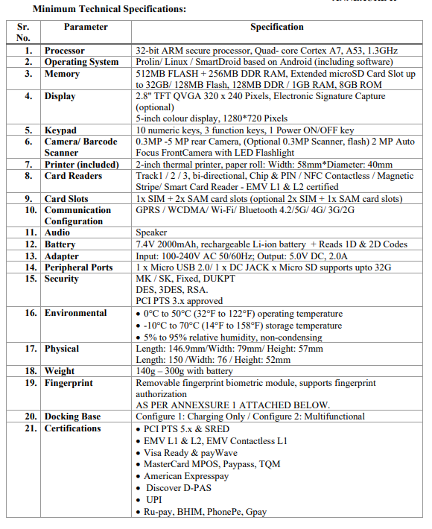

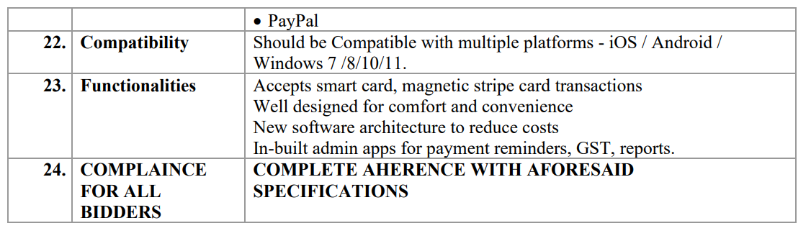

Annexure M

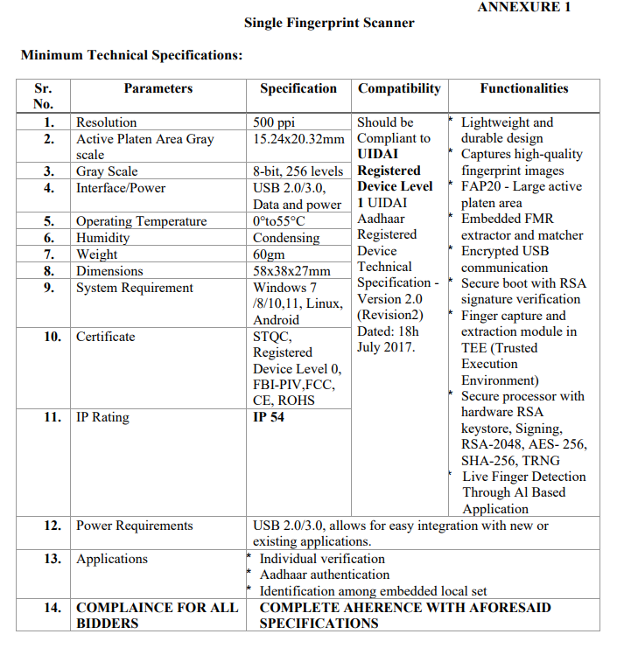

Annexure N

UNDERTAKING LETTER ON THE VENDOR’S LETTERHEAD FOR GST
To,
The Doorstep Banking Project Manager
PSB Alliance Private Limited,
Unit No 1, 3rd Floor, VIOS Commercial Tower,
Wadala East,
Mumbai- 400 037

Dear Sir / Madam,

EOI FOR SELECTION OF BUSINESS CORRESPONDENTS FOR PROVIDING DOORSTEP BANKING SERVICES THROUGH DOORSTEP BANKING AGENTS EOI REFERENCE NO. PSBA/DSBSR/2026-27/0260 DATED: 07-08-2026

EOI REFERENCE NO. PSBA/DSBSR/2026-27/0260DATED: 07-08-2026

Further to our proposal dated [•], in response to the EOI Reference No. PSBA/DSBSR/2026-27/0260 Dated:07-08-2026issued by PSB Alliance Private Limited (“Company”), we the Vendor M/s [•], hereby agree to comply with all applicable GST Laws including GST Acts, Rules, Regulations, Procedures, Circulars & Instructions thereunder applicable in India from time to time and to ensure its compliance.

Yours faithfully,

For: [•]

(Signature and seal of authorized person)
Name:
Designation:
Place:
Date:

Annexure P
[Name and Address of Vendor]
Sr. No | State/UT | Metro | Urban | Semi-Urban | Rural
1 | ANDAMAN & NICOBAR ISLANDS
2 | ANDHRA PRADESH
3 | ARUNACHAL PRADESH
4 | ASSAM
5 | BIHAR
6 | CHANDIGARH
7 | CHHATTISGARH
8 | DADRA AND NAGAR HAVELI AND DAMAN AND DIU
9 | GOA
10 | GUJARAT
11 | HARYANA
12 | HIMACHAL PRADESH
13 | JAMMU & KASHMIR
14 | JHARKHAND
15 | KARNATAKA
16 | KERALA
17 | LADAKH
18 | LAKSHADWEEP
19 | MADHYA PRADESH
20 | MAHARASHTRA
21 | MANIPUR
22 | MEGHALAYA
23 | MIZORAM
24 | NAGALAND
25 | NCT OF DELHI
26 | ODISHA
27 | PUDUCHERRY
28 | PUNJAB
29 | RAJASTHAN
30 | SIKKIM
31 | TAMIL NADU
32 | TELANGANA
33 | TRIPURA
34 | UTTAR PRADESH
35 | UTTARAKHAND
36 | WEST BENGAL
Submit presence by marking Yes or no against respective State and Centre \ Area.

